TOGAF® Standard – Architecture Vision
Version 1.0
July 2026
Barangay San Antonio Health Department Enterprise Architecture
Barangay San Antonio Health Center, Pasig City
Document Version History
Version Number | Version Date | Revised By | Description | Filename
1.0 | October 22, 2026 | UA&P Solution Architecture team | First issue, based on interviews (October 2–21, 2026) and verification answers (October 22, 2026) | A1 - Architecture Vision.docx

Contents
1. Purpose of this Document 4
1.1 Output and Input 4
2. Problem Description 5
2.1 Stakeholders and their Concerns 5
2.2 List of Issues/Scenarios to be Addressed 6
3. Statement of Architecture 8
4. Summary Views 9
4.1 Value Chain Diagram 9
4.2 Solution Concept Diagram 10
5. Mapped Stakeholders Requirements 11
6. Draft Architecture Definition Document Reference 12
A Abbreviations 13
Tracking Information
Project Name | Barangay San Antonio Health Department Enterprise Architecture
Prepared By | Rome Victor Mag-iba Sendin (Group Leader); Samuel Anthonius Badillo; Wilson Halim; Kevin Enrico Ang | Document Version No. | 1.0
Title | Architecture Vision | Document Version Date | October 22, 2026
Reviewed By | Dr. Glynnis Lynn U. Bonilla, Medical Officer IV (Executive Sponsor) | Review Date | October 23, 2026
Distribution List
From | Date | Phone/Email
Rome Victor Mag-iba Sendin, Group Leader, UA&P Solution Architecture | October 22, 2026 | romevictor.sendin@uap.asia / 09456315746

To | Action* | Due Date | Phone//Email
Dr. Glynnis Lynn U. Bonilla, Medical Officer IV | Approve | October 23, 2026 | bsahealthcenter@gmail.com
Hon. Thomas Raymond U. Lising, Punong Barangay | Review | October 23, 2026 | bsahealthcenter@gmail.com
Hon. Rachel Marie S. Rustia-Olarte, Co-Chair, Committee on Health & Nutrition | Review | October 23, 2026 | bsahealthcenter@gmail.com
Mr. Joel Pira, Instructor, Solution Architecture (UA&P) | Review | October 23, 2026 | joel.pira@uap.asia
* Action Types: Approve, Review, Inform, File, Action Required, Attend Meeting, Other (please specify)

Purpose of this Document
The Architecture Vision is created early on in the ADM cycle. It provides a summary of the changes to the enterprise that will accrue from successful deployment of the Target Architecture. The purpose of the Architecture Vision is to provide key stakeholders with a formally agreed outcome. Early agreement on the outcome enables the architects to focus on the detail necessary to validate feasibility. Providing an Architecture Vision also supports stakeholder communication by providing a summary version of the full Architecture Definition.
For this engagement, the Architecture Vision summarizes the changes that a successful roadmap would bring to the Barangay San Antonio Health Department, and is the basis for sponsor review before detailed architecture work.

Output and Input
The TOGAF® Content Framework (see Architecture Deliverables) identifies deliverables that are produced as outputs from executing the Architecture Development Method (ADM) cycle and potentially consumed as inputs at other points in the ADM.
This deliverable is produced, updated, and consumed by the ADM Phases:
Deliverable | Output from… | Input to…
Architecture Vision | A, E | B, C, D, E, F, G, H  Requirements Management

Problem Description

Stakeholders and their Concerns
Barangay San Antonio Health Center is the primary-care facility of Barangay San Antonio, Pasig City, operating under the Pasig City Health Department (CHD). It serves a barangay of about 13,000 residents (more than 17,000 including transients), 798 children under five, about 63 condominiums, and relocated San Antonio families in Tanay, Rizal (relocated around 2018). Its 16 on-site staff handled 657 patient visits last month: 360 consultations (Monday, Tuesday and Friday, 8–11 AM) and 297 maintenance-medicine pickups (Monday, Wednesday and Friday afternoons).
Stakeholder | Role | Key concerns (from interviews)
Hon. Thomas Raymond U. Lising | Punong Barangay; approves barangay budget | Medicine supply is residents' top complaint; 2027 priorities: first 1,000 days, senior care, chronic diseases (diabetes, hypertension, cholesterol); barangay autonomy
Hon. Rachel Marie S. Rustia-Olarte | Co-Chair, Committee on Health & Nutrition | Approves urgent health purchases with the Kapitan; condo wellness pop-ups; OPT Plus (not interviewed directly; per Kapitan, Treasurer and staff)
Ms. Rosalin S. Labayan | Barangay Treasurer | Health and nutrition budget (about ₱700,000 a year); medicine purchases (about ₱150,000 in 2026); vouchers and liquidation
Dr. Glynnis Lynn U. Bonilla (Executive Sponsor) | Medical Officer IV | Prescriptions retyped in EMR and PhilHealth YAKAP; no queuing system; health promotion to condo residents; health information management
Ms. Nita N. Hardman, RN | Rural Health Nurse; medicine custodian | Paperwork load; redundant Google Drive forms; manual inventory; hard copies hand-carried to City Hall; 30+ work group chats
Ms. Mafe B. Abong, RM | Rural Health Midwife | Monthly reports compiled from many sources; misfiled charts; pregnancy target (60–70 of 181 reached)
Dr. Joseph P. Magpali, DMD | Rural Health Dentist | Separate dental system; low preventive uptake; one dentist for 13,000–17,000 people (WHO: 1:5,000)
Mr. Christian Jay G. Vasquez, RND | Nutritionist-Dietitian | Pays for own cloud storage; OPT files of 2–3 GB; PPAN targets; system-level support
Ms. Mary Anne M. Verches | Barangay Nutrition Scholar | Field encoding; condo access; Tanay coverage; complete weighing kit
Mr. Tito F. Reyes | IT Officer / Medical Encoder | EMR, PhilHealth and LMIS encoding load; weak LGU internet; City controls software
Pasig Health Aides and BHWs | Frontline care and field work | No assigned computers; paper logbooks; field reports
Pasig City Health Department (Dr. Joseph R. Panaligan, CHO) | Approves process and system changes (external) | Compliance; City-wide systems; report review
Patients, condo residents, Tanay families | Service users | Waiting order; medicine availability; access

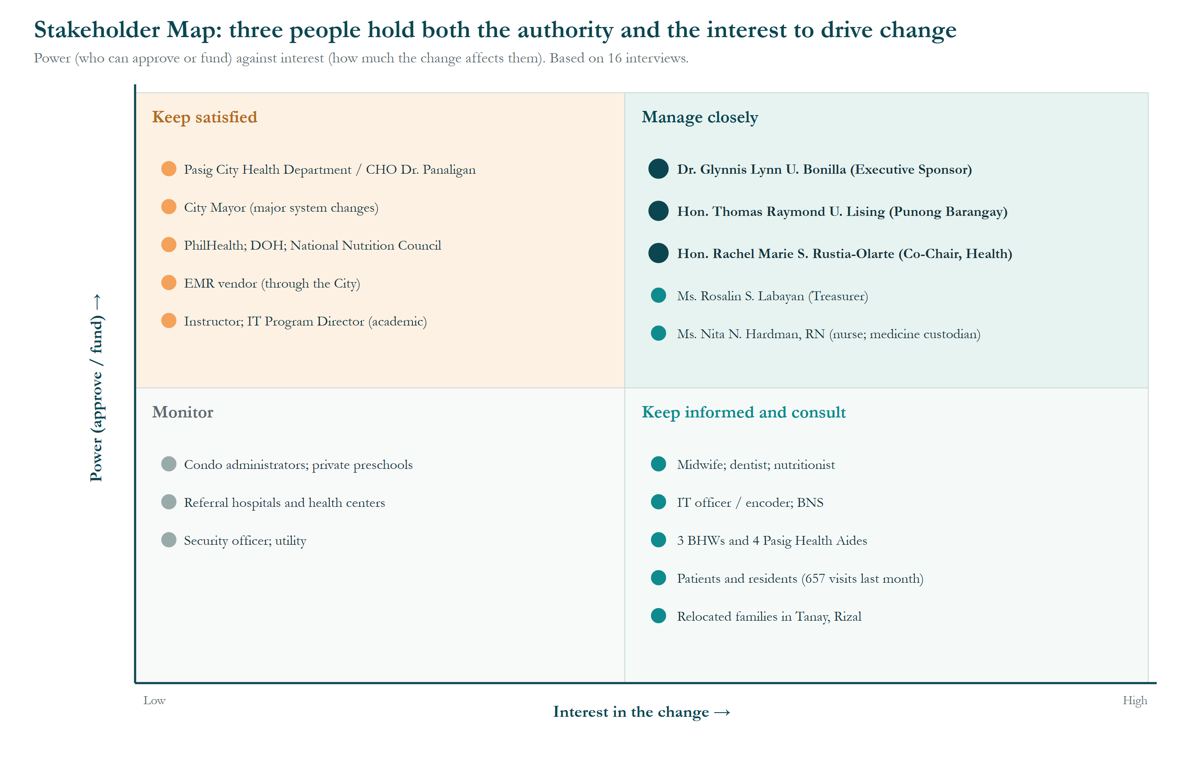
Figure 1. Stakeholder Map (power × interest).
How to read it: each person or group is placed by power (can approve or fund change, vertical axis) and interest (how much the change affects their work, horizontal axis). The quadrant decides how the team engages them.
- Manage closely: Dr. Bonilla, Kapitan Lising and Kagawad Rustia-Olarte both decide and are affected, so they review every deliverable.
- Keep satisfied: the City Health Department and City Health Officer, the City Mayor, PhilHealth, DOH, NNC and the EMR vendor hold approval power over systems but are not involved day to day; they are reached through formal letters (WP8).
- Keep informed and consult: the Treasurer, nurse, midwife, dentist, nutritionist, encoder, BNS, aides and BHWs run the processes; their interviews are the main evidence for this project.
- Monitor / inform: patients (657 visits last month), Tanay relocatees, condo administrators and referral hospitals are affected by results rather than decisions.

List of Issues/Scenarios to be Addressed
1. Business vision statement for the Target Architecture
“Every patient has one record, every service is entered once, medicines are on hand when needed, and staff spend their time on care rather than paperwork.”
2. Business context
See the Value Chain diagram (Section 4.1) and the Stakeholder Map (Figure 1).
3. Change drivers and opportunities
# | Issue / scenario | Evidence (source)
I-1 | A patient's medicines are written on the chart, typed in the EMR and retyped in PhilHealth YAKAP during a busy morning | Dr. Bonilla; Dr. Magpali
I-2 | Maintenance medicines (Metformin, Losartan, Amlodipine) ran short for three months; the barangay bought about ₱150,000 of stock with no reimbursement | Ms. Abong; Treasurer; Kapitan; verification Oct 22
I-3 | Internet slows or drops (about 5 times a month); staff fall back to paper and encode later | Dr. Bonilla
I-4 | A misfiled chart delays an old patient's registration (up to 10 minutes) | Ms. Abong
I-5 | Month-end reports are compiled from many sources, often into the evening, then printed, signed and hand-carried to the old City Hall | Ms. Abong; Nurse Hardman
I-6 | Patients queue first come, first served, which leads to complaints | Dr. Bonilla
I-7 | Work files and chats are on personal accounts; the nutritionist pays for extra storage himself | Mr. Vasquez; Nurse Hardman
I-8 | Condo residents decline visits and services, lowering program coverage (pregnancies reached: 60–70 of 181) | Dr. Bonilla; Ms. Verches; Ms. Abong

Statement of Architecture
See the Statement of Architecture Work (A2) for title, scope, roles, schedule and acceptance criteria. In summary, the engagement studies all operations of the Barangay San Antonio Health Department and delivers a roadmap that keeps the City EMR as the system of record and improves what the barangay and health center control, plus a documented case for City-level changes.
Goal | Measure of success (proposed)
G1 Enter data once | Prescription entries per consultation: up to 3 → 1
G2 Keep medicines in stock | Months with maintenance-medicine stock-outs: 3 (2026) → 0
G3 Faster records and reports | Old-patient record retrieval: up to 10 minutes → under 1 minute; no after-hours report compilation
G4 Official, secure work tools | Work files on personal accounts: most → none
G5 Better patient flow and reach | Fewer queue complaints; higher coverage of condo residents

Summary Views
The summary views below support the Request for Architecture Work and the draft Business, Data, Application and Technology Architectures.

Value Chain Diagram
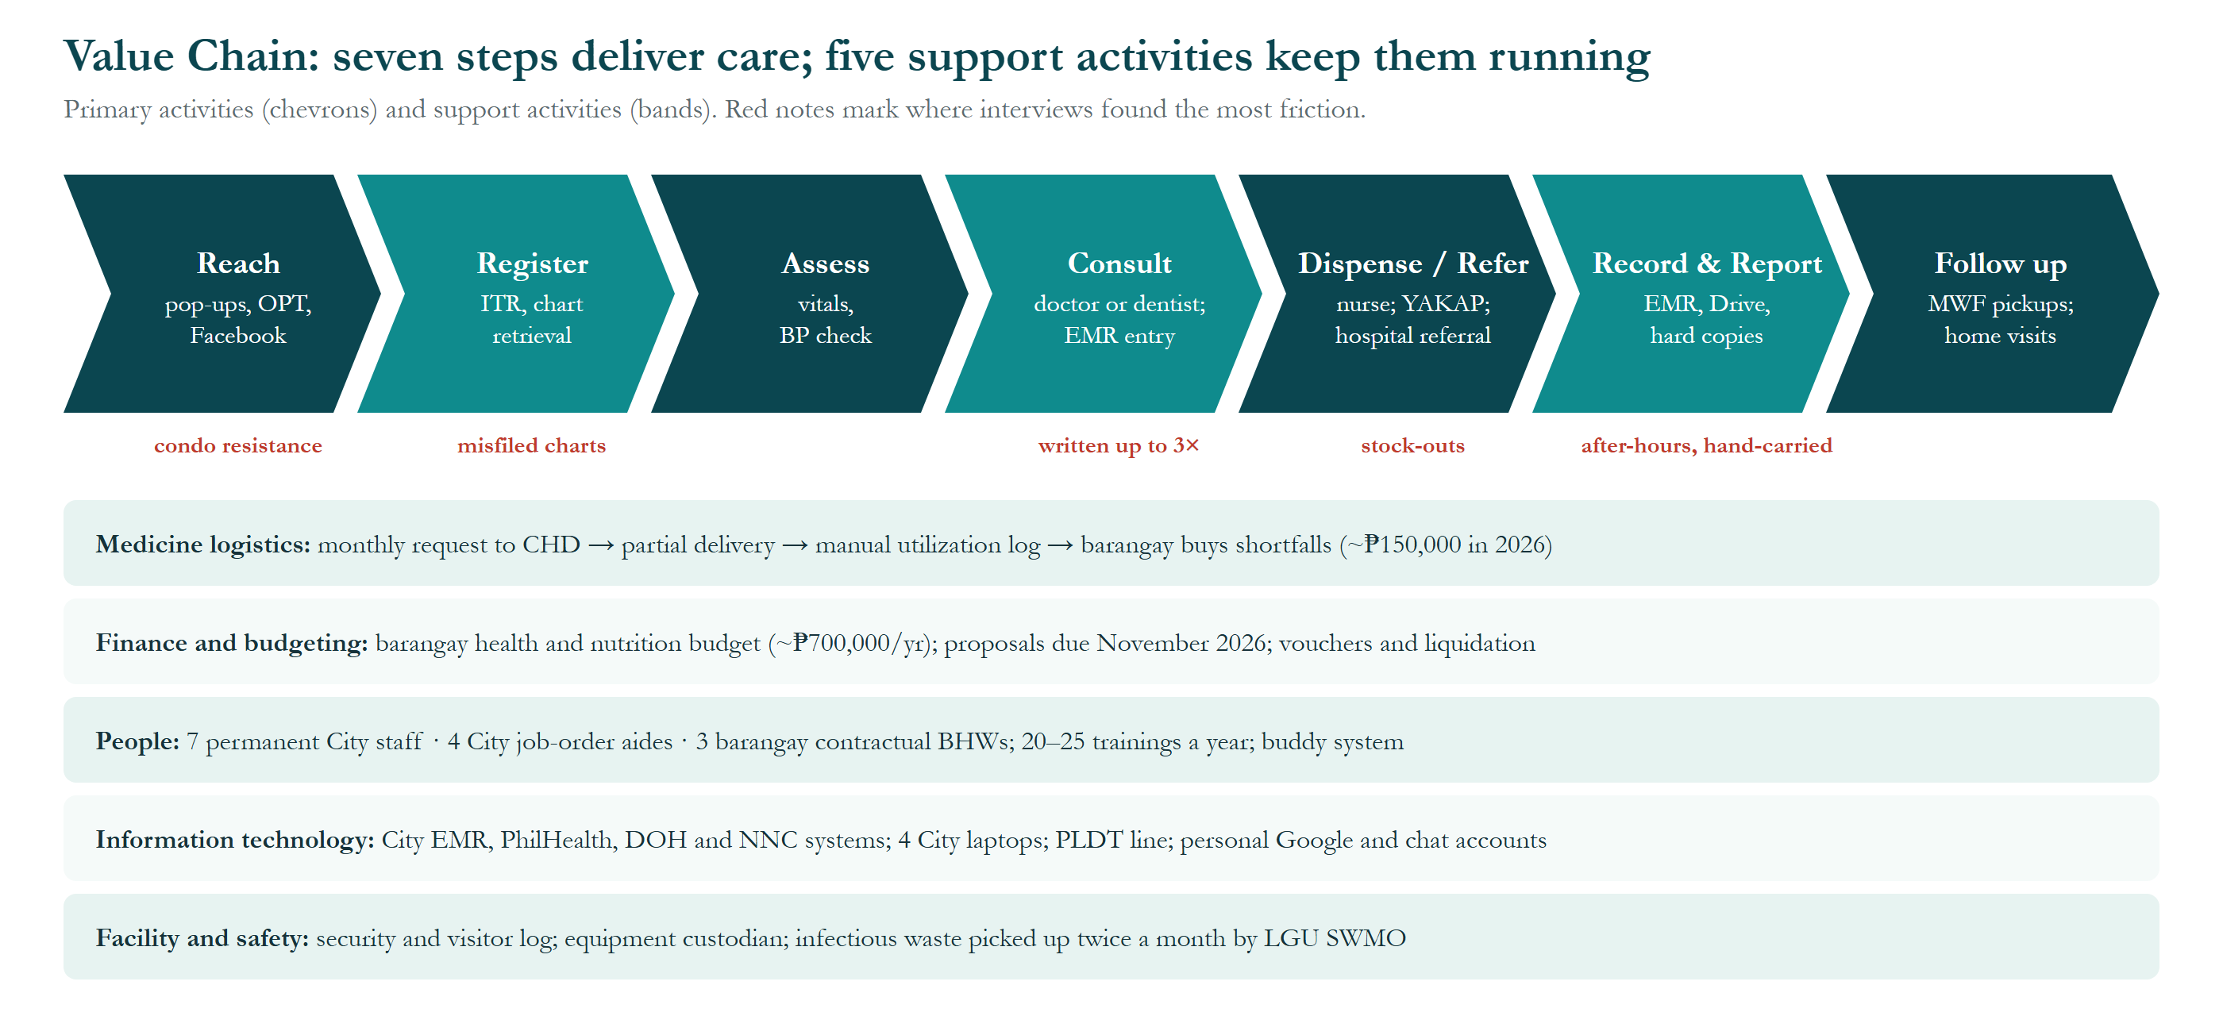
Figure 2. Value Chain of the Barangay San Antonio Health Department.
How to read it: the arrows across the top are the seven primary activities in the order a resident experiences them: Reach → Register → Assess → Consult → Dispense/Refer → Record & Report → Follow up. The bands underneath are support activities. Red notes are friction points named in the interviews.
- Register: about 8,000 paper charts, active and inactive mixed; a misfiled chart takes up to 10 minutes to find.
- Consult and dispense: each prescription is written on the chart, typed in the EMR and retyped in PhilHealth YAKAP.
- Medicine logistics: Metformin, Losartan and Amlodipine ran short for three months in 2026; the barangay covered about ₱150,000.
- Record and report: reports are compiled after hours and carried to City Hall as signed hard copies.
- Reach: condo residents often decline visits, lowering program coverage.
- Takeaway: the friction is where information is copied, not in the clinical care itself.

Solution Concept Diagram
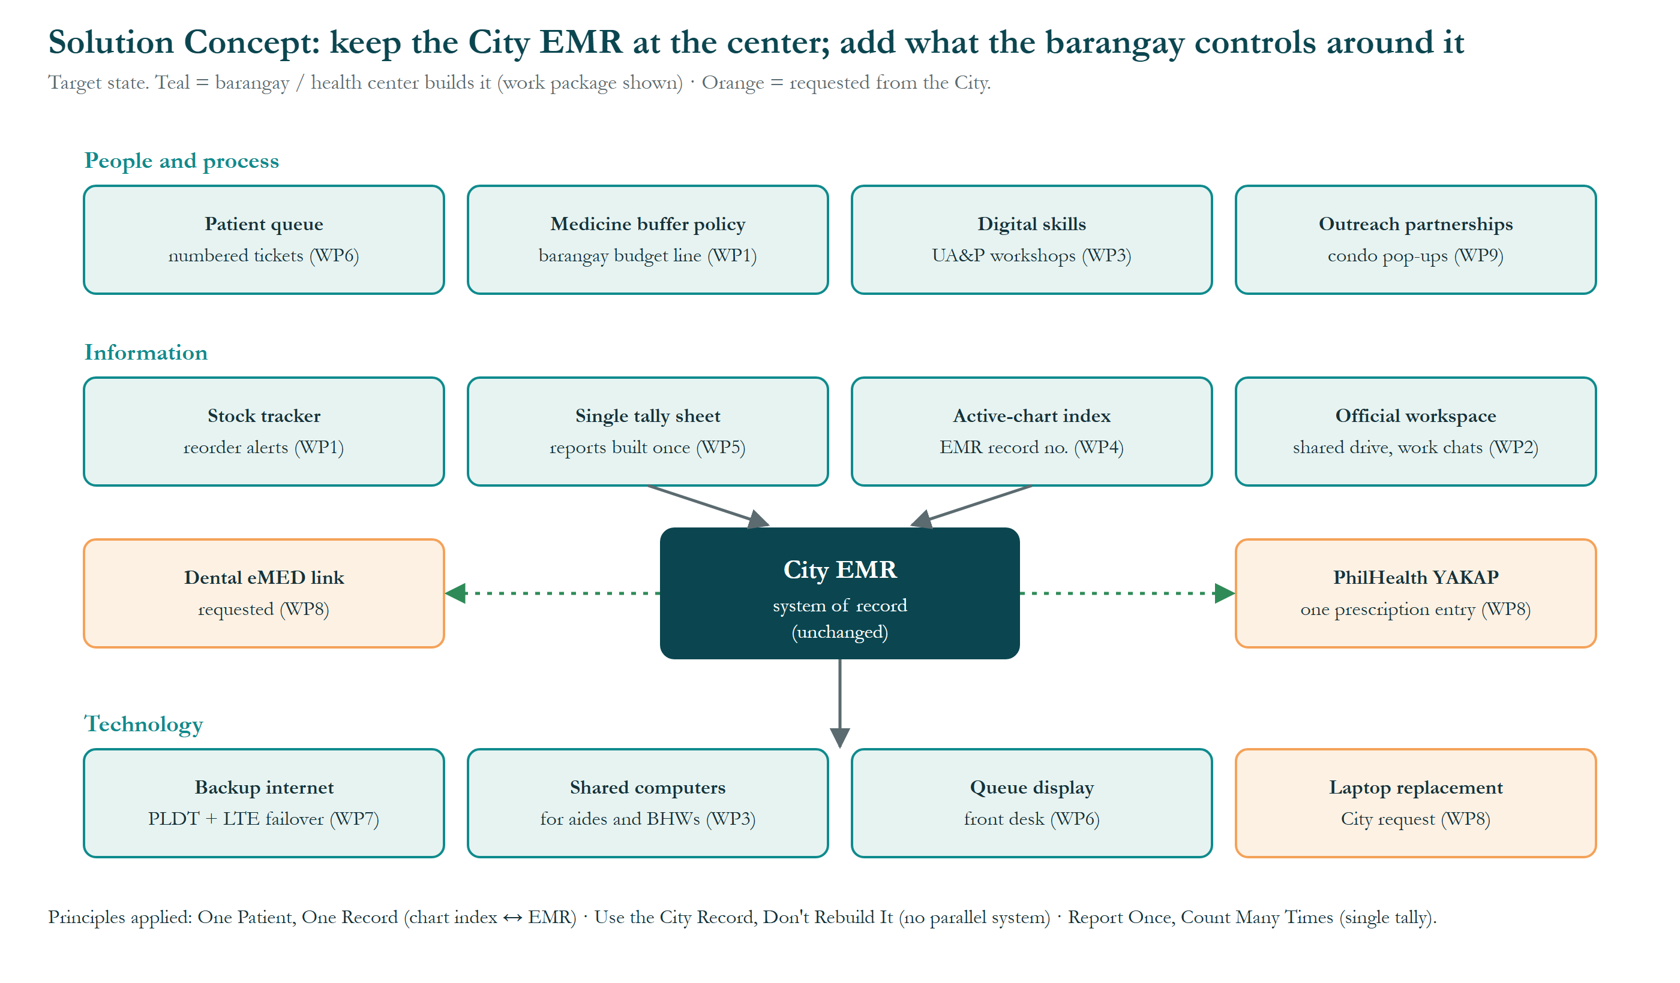
Figure 3. Solution Concept (target state).
How to read it: the City EMR sits at the center as the system of record and does not change. Boxes around it are grouped in three layers. Teal boxes are built by the barangay or health center (work package in brackets); orange boxes are requests to the City.
- People and process: numbered patient queue (WP6), medicine buffer budget line (WP1), digital-skills workshops (WP3), condo outreach partnerships (WP9).
- Information: stock tracker with reorder alerts (WP1), single tally sheet (WP5), active-chart index keyed to the EMR record number (WP4), official workspace (WP2); requested: one prescription entry shared with YAKAP and a dental eMED link (WP8).
- Technology: backup internet with LTE failover (WP7), shared computers for aides and BHWs (WP3), queue display (WP6); requested: replacement of the City laptops (WP8).
- Takeaway: no box creates a second patient database, applying the principle “Use the City Record, Don't Rebuild It”.

Mapped Stakeholders Requirements
ID | Requirement | Raised by | Phase | Priority
R-01 | Enter each prescription once and share it with PhilHealth YAKAP | Dr. Bonilla, Dr. Magpali | C | High
R-02 | Track medicine stock daily with alerts before stock runs out | Nurse Hardman, Kapitan Lising | B/C | High
R-03 | Keep a barangay buffer budget for maintenance medicines | Kapitan Lising, Treasurer | B/E | High
R-04 | Provide computers for Pasig Health Aides and BHWs | Ms. Intalan, Ms. Roa, Mr. Pestaño | D | High
R-05 | Provide an official shared workspace and storage | Mr. Vasquez, Nurse Hardman | C/D | Medium
R-06 | Introduce a numbered patient queue | Dr. Bonilla | B/D | Medium
R-07 | Reduce redundant report forms and hard-copy submission | Nurse Hardman, Ms. Abong | B | Medium
R-08 | Provide a backup internet connection | Dr. Bonilla, Mr. Reyes | D | Medium
R-09 | Keep paper as fallback for outages and follow-up notes | Ms. Abong | B | Required
R-10 | Comply with the Data Privacy Act and DOH 7-year retention | Ms. Abong, Nurse Hardman | All | Required
R-11 | Train staff in basic computer skills | Dr. Bonilla, Ms. Verches | B | Medium
R-12 | Strengthen health promotion to condo residents | Dr. Bonilla, Dr. Magpali, Kagawad Rustia | B/E | Medium

Draft Architecture Definition Document Reference
The baseline and target architectures are documented in the Architecture Definition Document (A5) and the phase deliverables: Architecture Deliverables – Phase B, Phase C and Phase D, and the Architecture Requirements Specification. The evidence base is the Interview Findings document (file 11).

- Abbreviations
Abbreviations, acronyms and reference codes used in this document and its figures, in alphabetical order.
Abbreviation | Meaning
ADM | Architecture Development Method, the step-by-step method of the TOGAF Standard
BHW | Barangay Health Worker
BNS | Barangay Nutrition Scholar
BP | Blood pressure
CHD | City Health Department (Pasig City)
CHO | City Health Officer
DMD | Doctor of Dental Medicine
DOH | Department of Health
eMed / eMED | Name of the City's electronic medical record system; “dental eMED” is its separate dental system
EMR | Electronic Medical Record
G1 … G5 | Goal reference number
GB | Gigabyte (a unit of file size)
Hon. | Honorable (title of elected officials)
I-1 … | Issue or scenario reference number
IT | Information technology
ITR | Individual Treatment Record (the patient's registration form)
LGU | Local Government Unit
LMIS | Logistics Management Information System
LTE | Long-Term Evolution (4G mobile internet)
MWF | Monday, Wednesday and Friday
NNC | National Nutrition Council
OPT / OPT Plus | Operation Timbang Plus: yearly weighing and measuring of children aged 0–59 months
PhilHealth | Philippine Health Insurance Corporation
PLDT | PLDT Inc., an internet and telephone provider
PPAN | Philippine Plan of Action for Nutrition
R-01 … | Stakeholder requirement reference number
RM | Registered Midwife
RN | Registered Nurse
RND | Registered Nutritionist-Dietitian
SWMO | Solid Waste Management Office (City of Pasig)
TOGAF | The Open Group Architecture Framework (the TOGAF® Standard)
UA&P | University of Asia and the Pacific
WHO | World Health Organization
WP1 … WP9 | Work package (a group of related changes delivered together)
YAKAP | PhilHealth Yaman ng Kalusugan Program (primary-care benefit)

